

Build a Data Mart in SQL
Phase 1 – Conception Phase

Course: DLBDSPBDM01
Tutor: Musharaf Doger
Name: Anita Skynar
Matriculation: 92124577
Submission Date: 27 August 2024

Project Overview (Adjusted)
1. Requirements Analysis
The design process began with analyzing platform requirements, focusing on three main roles: Guests, Hosts, and TravelAdmins. Each role’s actions and data needs were identified. The system was adjusted based on tutor feedback to clarify who can write reviews and to improve the realism of the payment flow.
Roles and Actions:
- Guests: Search for properties, book rentals, leave reviews, and manage profiles. The database handles these tasks by organizing and retrieving the necessary data effectively.
- Hosts: List properties, manage bookings, respond to guest queries, and leave reviews. Property details and availability are tracked in the database.
- TravelAdmins: Oversee the platform's operations, manage user accounts, handle customer service, and generate reports. Access to all stored data is required for reporting and operations.
Data and Functional Requirements:
Payment processing and transactions are now integrated, presenting a more realistic payment management. Reviews can now be written by both guests and hosts, providing a more accurate representation of how platform entities interact with each other. The database tracks users, listings, reservations, payments, and reviews, ensuring secure and reliable data handling.
2. Entity Relationship Model (ERM)
The revised ERM reflects an improved payment process, with attributes like TransactionType, PaymentMethod, and RefundProcessedDate for the transaction management. The Review entity allows both guests and hosts to leave reviews, with attributes like ReviewerType and ReviewerID. The model minimizes redundancy and ensures data integrity across the platform’s 22 entities, covering profiles, reservations, payments, and reviews.
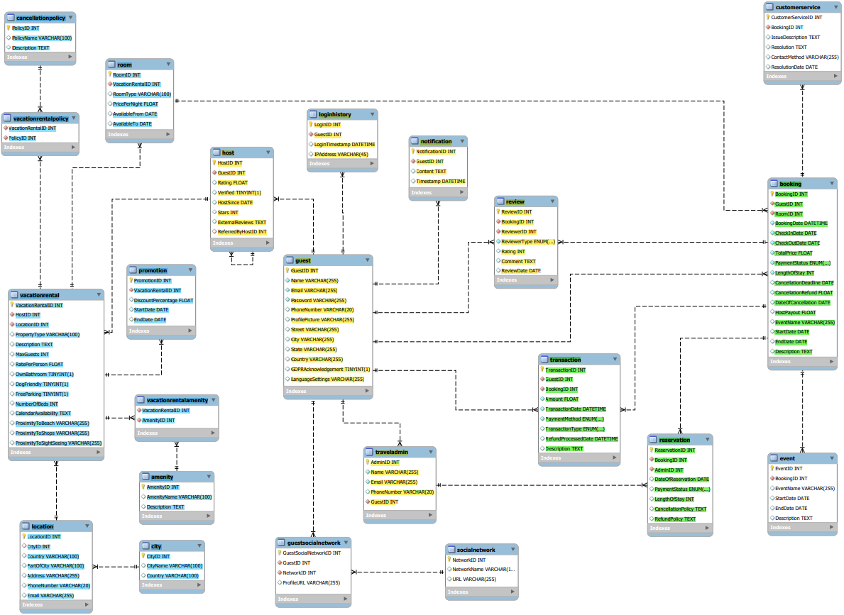
- Triple Relationships: Exist between tables like Guest, Booking, and Transaction to connect users, reservations, and payments. A similar structure connects Guest, Booking, and Review.
- Recursive Relationships: The Host table allows tracking referrals.
- Cardinality: Martin notation, also known as Crow’s Foot notation, is used to define relationships and cardinality between entities.
Normalization:
During the design process, normalization was prioritized to minimize redundancy and enhance data integrity. For example, the City entity collects city information, while full address details (street, state, country) are stored in appropriate entities. Foreign keys link tables as Location and VacationRental to maintain consistency without repeating data.

3. Tools and Documentation
MySQL Workbench was used for ERM creation, testing, and managing the design process. Each of the 22 entities is populated with 20 entries. The SQL code documentation contains information about the database structure and covers table creation, relationships, and sample data entries. The design's functionality was confirmed through test cases that verify the proper handling of bookings and payments.

4. Data Dictionary
1. Table: Guest
Column Name | Data Type | Constraints | Description
GuestID | INT | PRIMARY KEY, AUTO_INCREMENT | Unique identifier for guest
Name | VARCHAR(255) | NOT NULL | Guest's full name
Email | VARCHAR(255) | NOT NULL, UNIQUE | Guest's email address
Password | VARCHAR(255) | NOT NULL | Password for guest login
PhoneNumber | VARCHAR(20) |  | Guest's phone number
ProfilePicture | VARCHAR(255) |  | Guest’s profile picture
Street | VARCHAR(255) |  | Guest’s street address
City | VARCHAR(255) |  | City of guest
State | VARCHAR(255) |  | State or province of guest
Country | VARCHAR(255) |  | Country of guest
GDPRAcknowledgement | BOOLEAN |  | If guest acknowledges GDPR terms
LanguageSettings | VARCHAR(255) |  | Guest’s language
2. Table: Host
Column Name | Data Type | Constraints | Description
HostID | INT | PRIMARY KEY, AUTO_INCREMENT | Unique identifier for host
GuestID | INT | FOREIGN KEY (GuestID) | Reference to guest who is a host
Rating | FLOAT |  | Host's rating
Verified | BOOLEAN |  | If the host is verified
HostSince | DATE |  | Date since they are a host
Stars | INT |  | Number of stars rating for host
ExternalReviews | TEXT |  | External reviews for the host
ReferredByHostID | INT | FOREIGN KEY (HostID) | Recursive reference to referring host
3. Table: TravelAdmin
Column Name | Data Type | Constraints | Description
AdminID | INT | PRIMARY KEY, AUTO_INCREMENT | Unique identifier travel admin
Name | VARCHAR(255) | NOT NULL | Admin’s full name
Email | VARCHAR(255) | NOT NULL, UNIQUE | Admin’s email address
PhoneNumber | VARCHAR(20) |  | Admin’s phone number
GuestID | INT | FOREIGN KEY (GuestID) | Reference to guest
4. Table: SocialNetwork
Column Name | Data Type | Constraints | Description
NetworkID | INT | PRIMARY KEY, AUTO_INCREMENT | Unique identifier for social network
NetworkName | VARCHAR(100) |  | Name of social network
URL | VARCHAR(255) |  | URL of the social network
5. Table: GuestSocialNetwork
Column Name | Data Type | Constraints | Description
GuestSocialNetworkID | INT | PRIMARY KEY, AUTO_INCREMENT | Unique identifier for guest social network
GuestID | INT | FOREIGN KEY (GuestID) | Reference to guest
NetworkID | INT | FOREIGN KEY (NetworkID) | Reference to social network
ProfileURL | VARCHAR(255) |  | URL to guest’s social profile
6. Table: LoginHistory
Column Name | Data Type | Constraints | Description
LoginID | INT | PRIMARY KEY, AUTO_INCREMENT | Unique identifier for login history
GuestID | INT | FOREIGN KEY (GuestID) | Reference to guest
LoginTimestamp | DATETIME |  | Timestamp of guest login
IPAddress | VARCHAR(45) |  | IP address used during login
7. Table: Notification
Column Name | Data Type | Constraints | Description
NotificationID | INT | PRIMARY KEY, AUTO_INCREMENT | Unique identifier for notification
GuestID | INT | FOREIGN KEY (GuestID) | Reference to guest
Content | TEXT |  | Content of the notification
Timestamp | DATETIME |  | Time of the notification
8. Table: City
Column Name | Data Type | Constraints | Description
CityID | INT | PRIMARY KEY, AUTO_INCREMENT | Unique identifier for city
CityName | VARCHAR(100) |  | Name of the city
Country | VARCHAR(100) |  | Country of the city
9. Table: Location
Column Name | Data Type | Constraints | Description
LocationID | INT | PRIMARY KEY, AUTO_INCREMENT | Unique identifier for location
CityID | INT | FOREIGN KEY (CityID) | Reference to city
Country | VARCHAR(100) |  | Country of the location
PartOfCity | VARCHAR(100) |  | Sub-part of the city
Address | VARCHAR(255) |  | Full address of the location
PhoneNumber | VARCHAR(20) |  | Contact phone number
Email | VARCHAR(255) |  | Contact email address
10. Table: VacationRental
Column Name | Data Type | Constraints | Description
VacationRentalID | INT | PRIMARY KEY, AUTO_INCREMENT | Unique identifier for vacation rental
HostID | INT | FOREIGN KEY (HostID) | Reference to host
LocationID | INT | FOREIGN KEY (LocationID) | Reference to location
PropertyType | VARCHAR(100) |  | Type of property
Description | TEXT |  | Description of vacation rental
MaxGuests | INT |  | Maximum guests allowed
RatePerPerson | FLOAT |  | Rate charged per person
OwnBathroom | BOOLEAN |  | If rental has its own bathroom
DogFriendly | BOOLEAN |  | If rental is dog-friendly
FreeParking | BOOLEAN |  | If free parking is available
NumberOfBeds | INT |  | Number of beds in rental
CalendarAvailability | TEXT |  | Calendar of rental availability
ProximityToBeach | VARCHAR(255) |  | Distance from the beach
ProximityToShops | VARCHAR(255) |  | Distance from shops
ProximityToSightSeeing | VARCHAR(255) |  | Distance from sightseeing spots
11. Table: Room
Column Name | Data Type | Constraints | Description
RoomID | INT | PRIMARY KEY, AUTO_INCREMENT | Unique identifier for room
VacationRentalID | INT | FOREIGN KEY (VacationRentalID) | Reference to vacation rental
RoomType | VARCHAR(100) |  | Type of room
PricePerNight | FLOAT |  | Price charged per night
AvailableFrom | DATE |  | Availability start date
AvailableTo | DATE |  | Availability end date
12. Table: Amenity
Column Name | Data Type | Constraints | Description
AmenityID | INT | PRIMARY KEY, AUTO_INCREMENT | Unique identifier for amenity
AmenityName | VARCHAR(100) |  | Name of the amenity
Description | TEXT |  | Description of the amenity
13. Table: VacationRentalAmenity
Column Name | Data Type | Constraints | Description
VacationRentalID | INT | FOREIGN KEY (VacationRentalID) | Reference to vacation rental
AmenityID | INT | FOREIGN KEY (AmenityID) | Reference to amenity
PRIMARY KEY (VacationRentalID, AmenityID) | Compound primary key (using both columns)
14. Table: CancellationPolicy
Column Name | Data Type | Constraints | Description
PolicyID | INT | PRIMARY KEY, AUTO_INCREMENT | Unique identifier for cancellation policy
PolicyName | VARCHAR(100) |  | Name of the policy
Description | TEXT |  | Description of the policy
15. Table: VacationRentalPolicy
Column Name | Data Type | Constraints | Description
VacationRentalID | INT | FOREIGN KEY (VacationRentalID) | Reference to vacation rental
PolicyID | INT | FOREIGN KEY (PolicyID) | Reference to cancellation policy
PRIMARY KEY (VacationRentalID, PolicyID) | Compound primary key using both columns
16. Table: Booking
Column Name | Data Type | Constraints | Description
BookingID | INT | PRIMARY KEY, AUTO_INCREMENT | Unique identifier for booking
GuestID | INT | FOREIGN KEY (GuestID) | Reference to guest
RoomID | INT | FOREIGN KEY (RoomID) | Reference to room
BookingDate | DATETIME | NOT NULL | Date and time of booking
CheckInDate | DATE | NOT NULL | Guest check-in date
CheckOutDate | DATE | NOT NULL | Guest check-out date
TotalPrice | FLOAT | NOT NULL | Total price for the booking
PaymentStatus | ENUM | ('Paid', 'Pending', 'Cancelled') | Payment status
LengthOfStay | INT | NOT NULL | Duration of stay in days
CancellationDeadline | DATE |  | Deadline to cancel without penalty
CancellationRefund | FLOAT |  | Refund amount if cancelled
DateOfCancellation | DATE |  | Date when booking was cancelled
HostPayout | FLOAT |  | Amount paid to host
EventName | VARCHAR(255) |  | Name of any associated event
StartDate | DATE |  | Start date of any associated event
EndDate | DAT |  | End date of any associated event
Description | TEXT |  | Additional description
17. Table: Transaction
Column Name | Data Type | Constraints | Description
TransactionID | INT | PRIMARY KEY, AUTO_INCREMENT | Unique identifier for transaction
GuestID | INT | FOREIGN KEY (GuestID) | Reference to guest
BookingID | INT | FOREIGN KEY (BookingID) | Reference to booking
Amount | FLOAT | NOT NULL | Transaction amount
TransactionDate | DATETIME | NOT NULL | Date and time of the transaction
PaymentMethod | ENUM | ('CreditCard', 'BankTransfer', etc.) | Payment method used
TransactionType | ENUM | ('Payment', 'Refund') | If transaction is a payment or refund
RefundProcessedDate | DATETIME |  | Date if refund was processed
Description | TEXT | NOT NULL | Description of the transaction (reason)
18. Table: Reservation
Column Name | Data Type | Constraints | Description
ReservationID | INT | PRIMARY KEY, AUTO_INCREMENT | Unique identifier for reservation
BookingID | INT | FOREIGN KEY (BookingID) | Reference to booking
AdminID | INT | FOREIGN KEY (AdminID) | Reference to travel admin
DateOfReservation | DATE |  | Date the reservation was made
PaymentStatus | ENUM | ('Paid', 'Pending', 'Cancelled') | Payment status
LengthOfStay | INT |  | Duration of stay in days
CancellationPolicy | TEXT |  | Cancellation policy details
RefundPolicy | TEXT |  | Refund policy details
19. Table: Review
Column Name | Data Type | Constraints | Description
ReviewID | INT | PRIMARY KEY, AUTO_INCREMENT | Unique identifier for review
BookingID | INT | FOREIGN KEY (BookingID) | Reference to booking
ReviewerID | INT | FOREIGN KEY (GuestID) | Reference to guest/host giving review
ReviewerType | ENUM | ('Guest', 'Host') | If review is from guest or host
Rating | INT |  | Rating provided in the review
Comment | TEXT |  | Review comments
ReviewDate | DATE |  | Date the review was posted
20. Table: CustomerService
Column Name | Data Type | Constraints | Description
CustomerServiceID | INT | PRIMARY KEY, AUTO_INCREMENT | Unique identifier for customer service issue
BookingID | INT | FOREIGN KEY (BookingID) | Reference to booking
IssueDescription | TEXT |  | Description of customer issue
Resolution | TEXT |  | Resolution to the issue
ContactMethod | VARCHAR(255) |  | Contact method used to address issue
ResolutionDate | DATE |  | Date issue was resolved
21. Table: Event
Column Name | Data Type | Constraints | Description
EventID | INT | PRIMARY KEY, AUTO_INCREMENT | Unique identifier for event
BookingID | INT | FOREIGN KEY (BookingID) | Reference to booking
EventName | VARCHAR(255) |  | Name of the event
StartDate | DATE |  | Event start date
EndDate | DATE |  | Event end date
Description | TEXT |  | Description of the event
22. Table: Promotion
Column Name | Data Type | Constraints | Description
PromotionID | INT | PRIMARY KEY, AUTO_INCREMENT | Unique identifier for promotion
VacationRentalID | INT | FOREIGN KEY (VacationRentalID) | Reference to vacation rental
DiscountPercentage | FLOAT |  | Percentage discount offered
StartDate | DATE |  | Promotion start date
EndDate | DATE |  | Promotion end date

